**37.How to create a data base and store & retrieve data from a data base in python?**

**Objective:**

* To create data base to store our data using python.

**Process:**

* Install sqlalchemy package from anaconda.
* Import create_engine object from sqlalchemy.
* Read the data set.
* Create data base engine by using create_engine method.
* Store our data set to the data base using data.to_sql().
* Retrieving the data using sqlite3 query.

**Input:**

* Data sample(csv file).

**Output:**

* Data base table for our data.

**Source code:**

#import libraries and sub-packages

from sqlalchemy import create_engine

import pandas as pd

#read the sample data set

data=pd.read_csv('/home/soft27/soft27/Sathish/

Pythonfiles/Employee.csv')

#Create the dtatbase engine

engine = create_engine('sqlite:///:memory:')

#store the data as a table

data.to_sql('data_table', engine)

#Query 1

result1 = pd.read_sql_query('SELECT * FROM data_table', engine)

print('Result 1')

print(result1)

#Query 2

result2 = pd.read_sql_query('SELECT name,sum(salary) FROM data_table group by name', engine)

print('Result 2')

print(result2)

**Screen shot:**

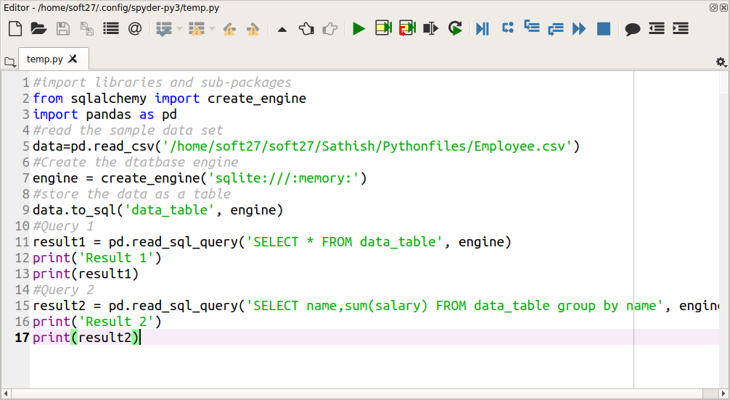

**Output:**

